Python script

|  |  |
| --- | --- |
| TEAM ID | PNT2022TMID36762 |
| NAME | BEENASHERIN.D |
| MARKS | 2 Marks |

CODE:

import random

print('Hazardous Water Level=',str(random.randint(0,100))) print('Temperature=',str(random.randint(0,100)))

print('Humidity=',str(random.randint(0,100)))

print('Presure=',str(random.randint(0,100)))

OUTPUT: 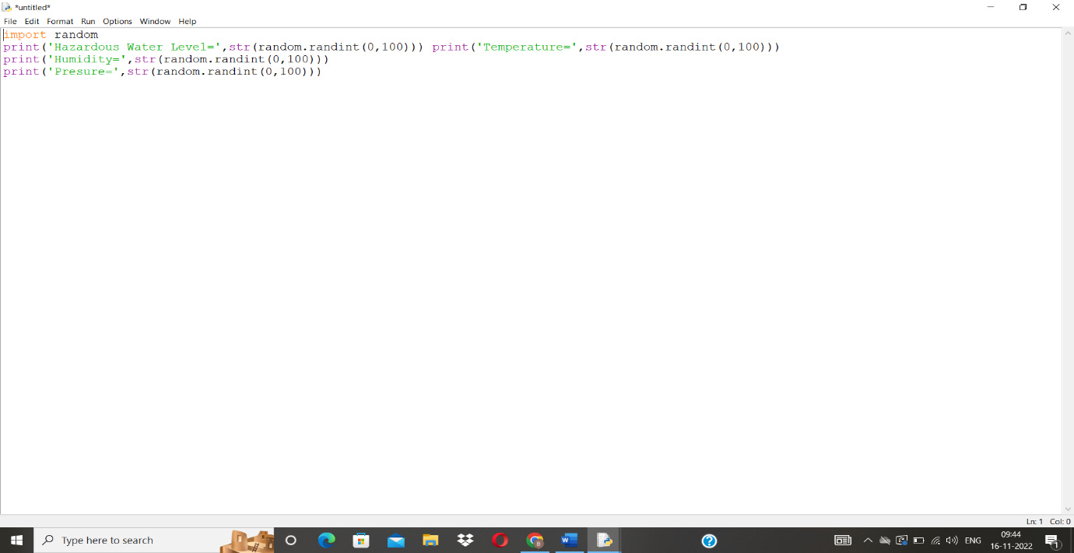

Output in python script:

